Investigating Emotional Granularity with Music

A thesis presented by

Fahim Ahmed

to
the Faculty of the Committee on Degrees in Neuroscience
in partial fulfillment of the requirements
for the degree
of Bachelor of Arts

Harvard University
Cambridge, Massachusetts
March 2025

Neuroscience Concentration

Division of Life Sciences

Harvard University

The Harvard College Honor Code

Members of the Harvard College community commit themselves to producing academic work of integrity – that is, work that adheres to the scholarly and intellectual standards of accurate attribution of sources, appropriate collection and use of data, and transparent acknowledgement of the contribution of others to their ideas, discoveries, interpretations, and conclusions. Cheating, plagiarizing or misrepresenting the ideas or language of someone else as one’s own, falsifying data, or any other instance of academic dishonesty violates the standards of our community, as well as the standards of the wider world of learning and affairs.

Digital Signature:_______________________________________________________

ACKNOWLEDGEMENTS
We’ll get there

LIST OF CONTRIBUTIONS
Will also get there
ABSTRACT
Emotional granularity is the degree to which people differentiate between their experiences of emotion. Measures of emotional granularity typically involve responding to affective images. Music listening is an emotionally evocative experience that allows listeners to traverse emotional space over time; thus, listening to music may involve more nuanced emotional experiences than viewing static pictures. We investigated emotional granularity in response to music listening and hypothesized that emotional granularity in response to music and pictures would be positively correlated, but that music would elicit a more granular emotional response than pictures. Adult participants (n = 73) were presented with 16 musical excerpts (8 positively- and negatively-valenced) and 16 affective images (8 positively- and negatively-valenced) from a standardized database. They then rated their emotional experience for each stimulus on 10 emotion words (5 positive: happy, relaxed, satisfied, joyful, and excited, and 5 negative: scared, anxious, upset, gloomy, and sad). Emotional granularity in response to these stimuli was calculated using intraclass correlation coefficient within positive and negative emotion words for pictures and music separately. Results showed significantly correlated emotional granularity between music and pictures across individuals, suggesting these methods tap into similar constructs. However, granularity was higher for music than for pictures for both positive and negative emotion granularity. Results reveal that music offers a powerful window into people’s perceptions of their emotional landscape. Structural MRI analyses of a separate sample of 50 adults showed a positive correlation between granularity and a cortical region implicated in the differentiation of emotional experiences.
INTRODUCTION
Music is known for its ability to evoke emotions and regulate mood (Juslin & Västfjäll, 2008; Schellenberg, 2003). Behavioral studies have shown that music elicits different emotional responses, and these differences are reflected in physiological changes, such as changes in heart rate, skin conductance responses, blood pressure, temperature, and respiration (Altenmüller et al., 2002; Panksepp & Bernatzky, 2002; Baumgartner et al., 2006; Krumhansl, 1997). These emotional experiences are one reason people enjoy listening to music (Sloboda, 2010; Dubé & Le Bel, 2003; Mas-Herrero et al., 2012). Feelings reported to be evoked by music include joy, love, longing, tenderness, sadness, anger, and fear, among others (Gabrielsson, 2010; Juslin & Laukka, 2003).
The neurological underpinnings of music-induced emotional responses are well-documented. Listening to music activates emotion and reward-related brain networks. Multiple studies have shown that music listening engages the mesolimbic dopaminergic system, a key pathway associated with reward and motivation (Mas-Herrero et al., 2021; Salimpoor et al., 2001; Salimpoor et al., 2013; Belden et al., 2023; Koelsch, 2014). The amygdala and medial temporal lobe are involved in evaluating emotional responses to music. These regions play critical roles in processing the emotional significance of musical stimuli (Dellacherie et al, 2008; Khalfa et al., 2008). Altenmüller et al. (2002) further explored the neural patterns associated with emotions elicited by music, finding cortical lateralization patterns that vary depending on the emotional content of the music. Baumgartner et al. (2006) demonstrated that music’s ability to evoke emotions can be seen by presenting individuals with auditory and visual emotional stimuli simultaneously, with presentation of similarly valenced auditory and visual stimuli causing greater activity in both subcortical and cortical regions than when visual emotional stimuli are presented alone. This suggests that even if individuals can identify the emotion that they are meant to perceive from the visual stimulus, emotion perception may not lead to a significant emotional experience without the presentation of a musical stimulus alongside the visual stimulus (Baumgartner et al., 2006). These insights demonstrate the intricate relationship between music, emotion, and neurobiology, offering compelling evidence for music’s ability to evoke profound emotional states (Kawakami et al., 2014; Koelsch, 2014, 2020; Brattico & Jacobsen, 2009; Schaefer, 2017).
Given music’s ability to evoke emotions, music is often used to regulate existing emotions, such as helping to energize, relieve tension and stress, and/or reduce feelings of loneliness (Wells & Hakanen, 1991; North et al., 2000; Pelletier, 2004; Granot et al., 2021). This music usage for emotion regulation has been observed across several countries, with a strong emphasis on maintaining well-being (Granot et al., 2021). Others may use music to intensify or align with their existing emotional states, such as listening to sad music while feeling sad, rather than using music to alter their emotional state (Chamorro-Premuzic & Furnham, 2007; Sachs et al., 2015). Music serves as a powerful tool for mood regulation, enabling individuals to achieve a range of emotional objectives. DeNora (1999) describes how music functions as a “technology of the self,” helping individuals construct and manage their emotional lives. Panksepp and Bernatzky (2002) highlight music’s evolutionary significance, suggesting that its capacity for emotional regulation may have adaptive benefits. Similarly, Juslin and Laukka (2003) and Pelletier (2004) discuss the strategic use of music for coping, stress relief, and emotional resilience. The significant involvement of music in activating reward and emotional brain circuits could explain why people value music. Zald and Zatorre (2011) emphasize the pleasure derived from music, while Chamorro-Premuzic and Furnham (2007) and Sloboda (2010) underscore its role in relaxation and stress relief. These findings highlight music’s utility in promoting emotional well-being and its centrality to human life.
To understand how emotions are evoked, it is necessary to have a theoretical model for experiencing emotion. One model for understanding emotions is the theory of constructed emotion. This theory is based on the tenet that our understandings of emotions are constructed from sensory experiences, where experiences that are similar to each other are used to “construct a categorization” of an emotion that captures all of those experiences (Barrett, 2006; Barrett, 2017). When we have experiences that do not seem to fit into an existing category, they can either form a new category, or they can direct us to modify our existing categories to accommodate these new experiences. These categories are known as emotion concepts, and when a sensory experience is categorized into an emotion concept, we experience that emotion in response to the sensory experience. This theory is a departure from the theory that emotions are innate, as it argues that individuals can experience different emotions based on their experiences and the emotion concepts they have constructed from those experiences rather than everyone experiencing a fixed set of basic emotions (Barrett, 2006). Different cultures experience and express emotions differently, given that our constructions of emotion concepts are dependent on our cultural knowledge, social contexts, and the language available to us to label those emotions (Lindquist et al., 2015).
These differences in emotional experience can be explained, in part, by a concept of emotional granularity. Emotional granularity refers to the ability to differentiate and label discrete emotional experiences with precision and specificity (Barrett et al., 2001; Tugade et al., 2004; Kashdan et al., 2015). It involves recognizing and distinguishing between variations within similarly valenced emotion categories, such as differentiating between feeling anger, sadness, or fear (Kashdan et al., 2015).
Typically, this ability to differentiate emotions is separated into negative emotions (i.e., negative emotional granularity) and positive emotions (positive emotional granularity), with negative emotional granularity having been studied more extensively than positive (Hoemann et al., 2021). Individuals with greater emotional granularity tend to be more capable of accurately identifying and articulating their emotions. The emotion words provided to participants are separated into negatively and positively valenced emotions, finding the correlation between responses for negative valence emotions, and the correlation between responses for positive valence emotions (Erbas et al., 2018). A high correlation between different emotions across stimuli suggests lower emotional granularity, as it indicates that the individual more frequently experiences different emotions together rather than being able to pinpoint and differentiate their emotions based on the type of stimulus.
One popular method to study emotional granularity involves participants reporting the extent to which they feel different emotions on a numerical scale after being exposed to various affective images (Nook et al., 2018; Kashdan et al., 2010; Pond et al., 2012; Tugade et al., 2004; Erbas et al., 2018) such as the International Affective Picture System (IAPS) and Open Affective Standardized Image Set (OASIS) (Coan & Allen, 2007; Kurdi et al., 2017). Emotional granularity is then measured using the intraclass correlation (ICC; Shrout & Fleiss, 1979) of participants’ responses across trials (Kashdan et al., 2010; Pond et al., 2012; Tugade et al., 2004; Kalokerinos et al., 2019; Nook et al., 2018). Emotion words commonly used for measuring positive emotional granularity in response to standardized stimuli include relaxed, happy, joyful, proud, excited, and satisfied (Erbas et al., 2016, 2018, 2022; Tugade et al, 2004; Nook et al., 2021; Baumgartner et al., 2006; Barrett et al., 2001; Vedernikova et al., 2021). Emotion words commonly used for measuring negative emotional granularity include angry, ashamed, disgusted, scared, fearful, sad, upset, anxious, depressed, nervous, and lonely (Nook et al., 2018, 2021; Erbas et al., 2014, 2016, 2019, 2022; Pond et al., 2012; Kashdan et al., 2010; Vedernikova et al., 2021). The Photo Emotion Differentiation (PED) task in particular is commonly administered, involving participants rating the extent to which they feel 20 different emotions when viewing 20 standardized affective images, one at a time (Erbas et al., 2014; Thompson et al., 2021).
Although tasks including responses to standardized stimuli are convenient in that they require low time and effort, are low cost, and can be administered online, they have low ecological validity (Thompson et al., 2021). Alternatively, longitudinal studies referred to as either experience sampling or ecological momentary assessments (EMA) may also be used to measure emotional granularity. In these studies, participants report the extent to which they feel a set of emotions repeatedly throughout the day for a certain time period. This allows researchers to measure emotional granularity in the context of the emotions people experience in their everyday lives, making for a highly ecologically valid measurement of granularity. In Erbas et al. (2019), emotional granularity scores from the PED task and EMA were only moderately associated (r ~ 0.22)
Differences in emotional granularity between individuals have only recently been related to differences in neuroanatomy. Higher emotional granularity is correlated with greater inferior frontal cortex (IFC) cortical thickness in older adults between 62–84 years old (Lukic et al., 2023). Greater cortical thickness has been found specifically in the right- and left-lateral orbitofrontal cortex, with the correlated cluster in the left hemisphere extending into the dorsal anterior insula. The IFC plays an important role in the controlled retrieval of information stored in semantic knowledge (Lau et al, 2008; Thompson-Schill et al., 1997). As part of the frontoparietal cortical network, the IFC also plays important roles in behavioral inhibition, cognitive control, and emotion regulation (Aron et al., 2014; Dörfel et al., 2014; Li et al., 2021; Ochsner et al., 2004; Phan et al., 2005; Picó-Pérez et al., 2019). Language usage for labeling and deriving meaning from the emotions expressed by others also activates the IFC (Brooks et al., 2017; Goldin et al., 2008; Hariri et al., 2000; Lieberman et al., 2005, 2007; Phan et al., 2005; Torre & Lieberman, 2018). The positive association between emotional granularity and IFC cortical thickness may underscore the importance of labeling one’s emotions in emotionally granular experiences.
##NEED TO ADD MORE BACKGROUND ON SPECIFIC ROIs IN IFC + BRAIN REGIONS IMPLICATED IN EMOTIONAL EXPERIENCES + LISTENING TO MUSIC
Understanding individuals’ abilities to differentiate between specific emotions is essential for understanding methods of emotion regulation and the long-term behavioral and mental outcomes thereof. High positive emotional granularity is linked to better mental health outcomes after negative events, as individuals with high emotional granularity specific for positive emotions are more capable of identifying positive elements within different experiences, helping them to cope and recover after stressful events (Tugade et al., 2004; Kang & Shaver, 2004; Kashdan et al., 2010). This capacity to recover from stressful events is known as resilience, measured in the past with the Ego-Resiliency Scale, (ER89; Block & Kremen, 1996) and more recently by the Connor-Davidson Resilience Scale (CD-RISC; Connor & Davidson, 2003). Individuals with high positive emotional granularity may be able to find positivity even within negative experiences, separating parts of a negative emotional experience into more specific components and focusing on the potential positives.
High negative emotional granularity is associated with better mental health outcomes specifically for depression (Willroth et al., 2020) and anxiety (Seah et al., 2020; Erbas et al., 2014; Starr et al, 2017). Higher negative emotional granularity indicates a better ability to differentiate between specific negative emotions, which can allow individuals to use targeted coping mechanisms rather than feeling a general negativity and being unable to isolate the cause of that negativity. Many studies measure these mental health outcomes using daily diary entries and repeated emotion ratings as part of a longitudinal study rather than using pre-existing validated scales like the Beck Depression Inventory-II (BDI-II; Beck et al., 1996) or State-Trait Anxiety Inventory for Adults (STAI; Spielberger, 1983) (Willroth et al., 2020; Erbas et al., 2014; Pond et al., 2012; Seah et al., 2020).
Music’s ability to evoke complex and varied emotions may provide a unique avenue for studying emotional granularity. Unlike static visual stimuli, musical experiences unfold dynamically over time, offering listeners opportunities to experience and differentiate a wide range of emotions (Bachorik et al., 2009; Koelsch, 2014). Part of this dynamic experience is “musical expectancy” and “tension,” where chord progressions around a specific tonal center can be altered, moving away from that tonal center and going against our expectation of what chords are to follow, creating musical tension (Koelsch, 2014). Changes in tempo, syncopation, and dissonance can also create tension, while consonance can decrease tension, particularly if this consonance is used to resolve dissonance. Another unique quality of music is its ability to mirror acoustic characteristics of speech that differ by emotion. For example, human speech expressing excitement may include the characteristics of 1) fast tempo, 2) loud volume, and 3) higher pitch, which can be reflected in music in a way that is not possible with visual stimuli (Koelsch, 2014; Juslin & Laukka, 2003).
An important framework for understanding music-evoked emotions is BRECVEMA, which includes eight mechanisms: “Brain Stem Reflex, Rhythmic Entrainment, Evaluative Conditioning, Contagion, Visual Imagery, Episodic Memory, Musical Expectancy, and Aesthetic Judgment” (Juslin, 2013). Under this framework, emotional responses are triggered by the brain stem reacting to acoustic properties of music, such as loudness or sudden changes in sound. Emotions also arise from the synchronization of the listener’s physiological rhythms (like their heartbeat), with the rhythm or tempo of the music. Music evokes emotions through learned associations, where a specific piece of music can become linked to a specific emotion over time. Emotional expressions in music can also cause listeners to mirror or “catch” those emotions like a “contagion” (Juslin, 2013). Music can induce emotions by evoking mental images or memories that have emotional significance to the listener, especially personal episodic memories. These dynamic qualities make music particularly well-suited for measuring emotional granularity.
Understanding individuals’ abilities to differentiate between specific emotions is essential for understanding methods of emotion regulation. Given that music is frequently used as a tool for emotion regulation, it may have a relationship to emotional granularity. Music’s emotionally dynamic nature may offer richer, more nuanced emotional experiences compared to static stimuli like visual images. Since musical stimuli do unfold over time, evoking varying emotional responses that more closely mirror real-life emotional experiences, they could provide more ecologically valid measures of emotional granularity, particularly in research focusing on stress and coping mechanisms. Given that music listening is commonly used for coping with stress, music might also play an important role in affecting individuals’ ability to regulate their emotions (Thoma et al., 2012). Therefore, investigating this role of music may improve methods of measuring and understanding emotional granularity.
Music’s dual role as an emotion-evoking and mood-regulating medium makes it an essential area of study for affective science. By bridging physiological, psychological, and neuroimaging research, we gain a deeper understanding of how music influences human emotion across cultures and contexts. The current body of literature provides robust evidence of music’s ability to activate reward-related brain networks, evoke complex emotional states, and serve as a tool for emotional regulation. Investigating the role of music in emotional granularity offers promising opportunities to enhance our understanding of emotion differentiation and its implications for well-being.
The Current Study
Across two studies, we compared emotional granularity experienced in response to both affective musical excerpts and OASIS images. Participants were exposed to either eight seconds of a musical excerpt or OASIS image and then rated their emotional experience on ten emotion words (five positive, five negative). For both studies, we hypothesized that 1) emotional granularity in response to music would be correlated with granularity in response to picture stimuli, 2) musical stimuli will yield greater emotional granularity than picture stimuli (i.e., greater emotion differentiation will be experienced in response to music than in response to picture stimuli), 3) both positive and negative emotional granularity in response to music would be positively correlated with the ability to discriminate emotions in music, and 4) we would replicate the positive relationship between positive emotional granularity and resilience (Tugade et al., 2004) and the negative correlation between negative emotional granularity and levels of depression (Willroth et al., 2020) and anxiety (Seah et al., 2020; Erbas et al., 2014). In the second study, we additionally hypothesized that we would replicate the positive correlation between emotional granularity and cortical thickness of the inferior frontal cortex cortical thickness (Lukic et al., 2023), using the same granularity task and musical emotion discrimination task as the first study but with the addition of structural magnetic resonance imaging.

STUDY 1
MATERIALS AND METHODS
Participants
In a pilot experiment with 61 participants and an effect size of r = 0.34, a power analysis indicated that a sample size of 65 would achieve 80% power to detect a significant correlation between positive emotional granularity measures from picture stimuli and musical stimuli at α = 0.05. Participants’ emotional granularity scores calculated from their ratings of emotions experienced in response to these stimuli were used to conduct this power analysis. The stimuli used in this pilot were therefore the same as the ones used in the present study (see Materials and Procedure). With this, 73 participants completed the study using the emotion rating task. 67 participants were undergraduate students at Northeastern University recruited through PsyLink who completed the task online for course credit, and 6 participants were individuals that completed the task in-person. One participant was excluded from analyses due to missing data for one stimulus in the emotion rating task, leading to a final sample size of 72. Demographic data for the sample are shown in Table 1. 2 participants from the online sample did not complete the Qualtrics survey that included a demographics survey. They are therefore included in the “No response” categories and have not been factored into the “age” demographic.
Table 1 Study 1 sample demographics
Demographic | Study 1 sample  (n = 72)
Age
Mean (SD) | 18.6 (0.77)
Range | 18–21 years
Sex
Male | 18 (25%)
Female | 51 (70.83%)
Prefer not to answer | 1 (1.39%)
No response | 2 (2.78%)
Gender
Man | 18 (25%)
Woman | 48 (66.67%)
Gender non-conforming | 2 (2.78%)
Genderfluid | 1 (1.39%)
Other gender identity | 1 (1.39%)
No response | 2 (2.78%)
Race/Ethnicity
American Indian or Alaska Native | 0 (0%)
Asian | 20 (27.78%)
Black or African American | 6 (8.33%)
Hispanic or Latino | 8 (11.11%)
Native Hawaiian or Other Pacific Islander | 0 (0%)
White | 29 (40.28%)
Two or more races | 6 (8.33%)
Prefer not to answer | 1 (1.39%)
No response | 2 (2.78%)
Demographic information for the Study 1 sample.
Note: 2 participants did not complete the Qualtrics survey and are indicated as “No response.” Their ages therefore have not been factored into the “age” demographic.
Materials
Picture stimuli used for the emotion rating task were drawn from the Open Affective Standardized Image Set (OASIS; Kurdi et al., 2017). OASIS includes 900 color images that depict humans, animals, objects, and scenes, all of which have normative affective valence and arousal ratings. We excluded images belonging to the “humans” category to avoid potential social biases in emotion appraisal (Watson & de Gelder, 2017), and then separated the images into four groups based on their valence and arousal ratings. We selected images that had the greatest magnitude of valence within their respective groups, selecting 4 images from each valence/arousal group (negative valence and low arousal, negative valence and high arousal, positive valence and low arousal, positive valence and high arousal). Pilot data showed a non-significant difference between emotion word ratings and emotional experiences for stimulus selection.
Musical stimuli were drawn from excerpts of original instrumental compositions used in Sachs et al. (2023). These pieces were experimentally composed to see responses to specific emotional music, specifically composed to portray one of five emotions: sad, anxious, joyous, calm, or dreamy (dreamy excerpts were excluded from analyses in Sachs et al., 2023). Because these stimuli contain transitions across emotional states, we drew our stimuli from portions of these compositions which were stable in a given emotion state according to normed data* Specifically, we used time-series valence/arousal data of these compositions to select 8-second excerpts. Chosen excerpts remained relatively constant in both valence and arousal space, remaining within one quadrant of valence and arousal throughout the 8 seconds, and transition periods between sections of the music were avoided. Excerpts that showed significant changes in valence and/or arousal were avoided, even if they stayed within the same quadrant. After meeting these qualifications, excerpts were then evaluated for accurate representation of specific affective states. For negative valence excerpts, we aimed to pick music in minor keys, as minor keys are generally associated with negative emotions in Western music (Hevner, 1935; Kawakami et al., 2014). For low arousal excerpts, we avoided onsets of specific instruments and less spectral flux within 8-second sections. Descending melodic structures were also commonly found in low arousal sections. Out of the 8 negative valence excerpts selected, 4 were from sections designated as “sad” by the composers in the original study, and 4 were from sections designated as “anxious” (Sachs et al., 2023). However, the normed data indicated that some of the “sad” sections were high arousal despite falling under our selection criteria for low arousal music, and some “anxious” sections fell within low arousal despite having more high arousal qualities such as instrument onsets and greater spectral flux. In order to match the ratio of low arousal to high arousal for the picture stimuli, we therefore relied on a combination of the normed data from Sachs et al., (2023) as well as the selection criterion by inspection that we’ve mentioned.
For the 8 positive valence musical excerpts, 6 were from sections designated as “joyous” by the original composers and 2 were from sections designated as “calm.” This discrepancy in high- to low-arousal excerpts for positive music stimuli was largely due to a lack of musically distinct melodies within “calm” sections. These excerpts were a mix of low and high arousal, with some “joyous” sections being in the low arousal quadrant and following our musical selection criteria for low arousal, while some “joyous” sections were placed in the low arousal quadrant despite sounding more similar to those in the positive valence high arousal quadrant, requiring us to prefer following our musical selection criteria over the exact valence and arousal values from the normative data.
The 10 emotion words used in this task (happy, joyful, excited, satisfied, relaxed, sad, anxious, upset, gloomy, scared) were chosen based on frequently used terms used in previous studies on emotional granularity (Diener et al., 1995; Barrett et al., 2001; Tugade et al., 2004; Kashdan et al., 2010; Erbas et al., 2018; Kalokerinos et al., 2019; Nook et al., 2021; Vedernikova et al., 2021), along with emotions elicited by music (Eerola & Saari, 2025; Hevner, 1936). Pilot data (n = 61) indicated that, across all of the emotion words selected, there is no difference between the magnitude of emotion elicited by music versus pictures with the selected stimuli (i.e., there were no emotional experiences distinctly absent from either music or pictures as a whole).
Procedure
Participants completed the study on Gorilla, an online behavioral research platform, and Qualtrics, an online survey platform. Informed consent was obtained in accordance with the IRB-approved protocol 31-8-23 at Northeastern University. After consenting on Gorilla, online participants completed a headphone check (Woods et al., 2017) to ensure that they could hear the musical stimuli properly. Participants were then given instructions on how to complete the emotion rating task, after which they were presented with two practice stimuli—one OASIS picture stimulus (not included in the actual set of stimuli) followed by an emotion word response rating screen and one music stimulus (not the same as any of the actual music stimuli but from the same compositions in Sachs et al. (2023)) followed by an emotion response rating screen. After confirming that the practice was completed, they were then presented with 16 affective musical excerpts (8 negatively- and 8 positively-valenced) and 16 OASIS images (8 negatively- and 8 positively-valenced) for 8 seconds each.
Presentation of these stimuli was randomized across stimulus type (i.e., visual and musical stimuli were presented randomly in the same block together). After the presentation of each stimulus, participants rated the degree to which they felt five positively-valenced emotions (happy, satisfied, excited, joyful, relaxed) and five negatively-valenced emotions (gloomy, upset, scared, sad, anxious) on a 0-100 scale, with 0 meaning “no experience of that emotion at all” and 100 meaning “maximum experience of that emotion.” This randomized presentation continued until the end of the 32 stimuli, at which point participants were redirected to Qualtrics, where they completed a series of self-report questionnaires, including the Connor-Davidson Resilience Scale (CD-RISC; Connor & Davidson, 2003), Beck Depression Inventory-II (BDI-II; Beck et al., 1996), and State-Trait Anxiety Inventory for Adults (STAI; Spielberger, 1983), as well as basic demographic questions.
At the end of the questionnaires, they were redirected to the third part of the task: the adaptive Musical Emotion Discrimination Test (aMEDT; MacGregor et al., 2023). This task involves listening to 18 pairs of short musical stimuli, where for each pair of stimuli, participants were asked to choose which stimulus expresses a certain emotion more (happy, angry, tender, sad, fearful). The aMEDT is adaptive in that a correct answer leads to the presentation of a pair of stimuli that are more difficult to discriminate between compared to the previous pair. Incorrect answers lead to the presentation of an easier pair of stimuli to discriminate between. The presentation of pairs of stimuli in the aMEDT was randomized. Emotion discrimination is measured based on a computationally-derived measure that considers both the number of correct answers on the test along with the difficulty of the items themselves. This measure ranges between –2.5 and 2.5, with more positive values representing a greater ability to discriminate between emotions in music.
Analysis Plan
Using the 0-100 scale emotion ratings, we calculated the intraclass correlation coefficient (ICC) of experienced emotion ratings as a measure of experienced emotional granularity in response to either music or visual stimuli. ICC scores were separated by ratings of positively- and negatively-valenced emotion words, for a total of four ICCs per individual. ICCs were calculated using the irr package in R. Specifically, ICC(3,k) was calculated using the icc function, where ICC(3,k) is a two-way mixed effects model for consistency based on the average values of each emotion category at a 95% confidence level (Shrout & Fleiss, 1979). Use of ICC(3,k) is consistent with previous research (Nook et al., 2021; Kalokerinos et al., 2019). ICCs with negative values were recoded as 0, since negative intraclass correlations represent maximum granularity (Hoemann et al., 2023) Since correlations are not usually normally distributed, ICCs were then Fisher r-to-z transformed, in accordance with previous research on emotional granularity (Barrett et al., 2001; Erbas et al., 2019). At this point, the ICCs are scaled such that lower values represent greater granularity (i.e., weaker correlation between emotions). To make the granularity score more intuitive, scores were then multiplied by –1 such that higher values represented greater levels of emotion differentiation, with 0 representing maximum granularity (Erbas et al., 2019). Combined granularity scores were calculated from the average of an individual’s positive and negative granularity, separated by stimulus type. This gives us a total of six granularity scores for each individual.
To calculate the correlations between positive emotional granularity in response to music and in response to pictures (and likewise for negative granularity as well as combined granularity), Pearson’s product moment correlation coefficients were calculated for: positive granularity (music) and positive granularity (pictures), negative granularity (music) and negative granularity (pictures), and combined granularity (music) and combined granularity (pictures). To calculate the magnitude differences between granularity scores (in the same pairs as above), we conducted paired samples t-tests at a 95% confidence level.
To determine the association between the ability to discriminate emotions in music (aMEDT score) and granularity in response to music, Pearson’s product moment correlation coefficients were calculated for positive granularity (music) and aMEDT score as well as negative granularity (music) and aMEDT score. Correlations between granularity and mental health survey measures were calculated similarly, with correlational tests between positive granularity (music) and resilience (CD-RISC score) and positive granularity (picture) and resilience, negative granularity (music) and depression (BDI-II score) and negative granularity (picture) and depression, and negative granularity (music) and anxiety (STAI score) and negative granularity (picture) and anxiety.
RESULTS
Each participant completed the granularity task and had six emotional granularity scores calculated based on their emotion response ratings: positive emotional granularity in response to music (M = –1.13, SD = 0.43, range = –2.35 to 0) and in response to pictures (M = –1.72, SD = 0.53, range = –2.99 to –0.57), negative emotional granularity in response to music (M = –0.78, SD = 0.44, range = –1.83 to 0) and in response to pictures (M = –1.34, SD = 0.50, range = –2.56 to –0.57), and combined emotional granularity as an average of an individual’s positive and negative granularity scores for music (M = –0.95, SD = 0.38, range = –1.73 to –0.10) and pictures (M = –1.53, SD = 0.46, range = –2.46 to –0.38) (Figure 1A–C).
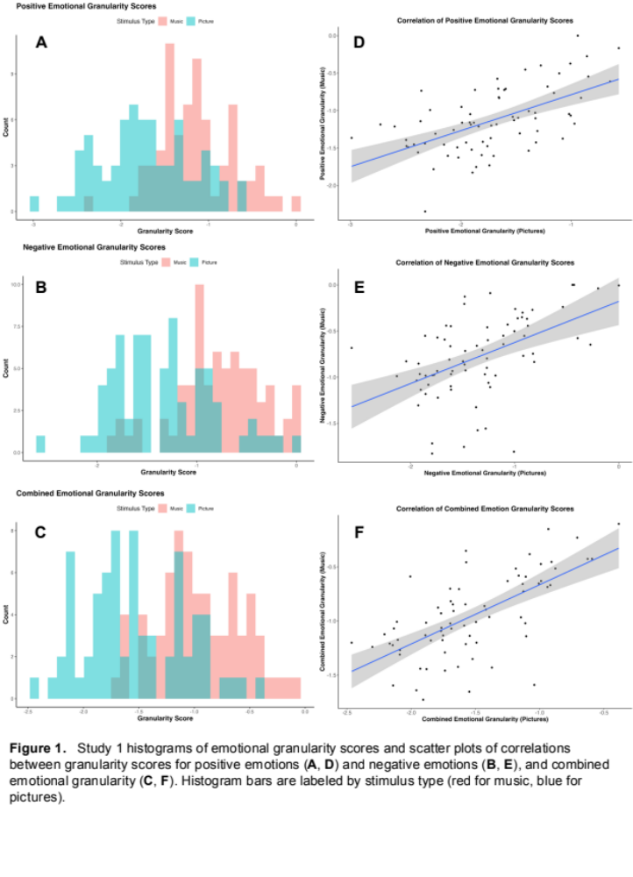

We first examined the relationship between emotional granularity measures in response to pictures and in response to music, separating by positive, negative, and combined scores (Figure 1D–F). Positive emotional granularity scores in response to music were found to be significantly positively correlated with positive granularity scores in response to pictures, r(70) = .58, p < .001. Negative emotional granularity scores were similarly positively correlated, r(70) =
0.51, p < .001, as was combined granularity, r(70) = 0.66, p < .001. These results aligned with our prediction that emotional granularity in response to music stimuli would be positively correlated with granularity in response to picture stimuli.
Emotional granularity in response to music was greater for music compared to pictures for positive (t(71) = 11.16 and p < .001), negative (t(71) = 10.28 and p < .001), and combined (t(71) = 13.80 and p < .001) granularity scores (Figure 2).
Our final sample size for the aMEDT was 60 due to missing data from some participants. We examined the relationship between emotional granularity in response to music and emotion discrimination within music (based on the aMEDT), finding a significant positive correlation between negative emotion granularity in response to music and musical emotion discrimination ability scores, r(58) = .33 and p = .014 (Figure 3A), and combined emotional granularity with aMEDT scores, r(58) = .31 and p = .019 (Figure 3B), but no significant correlation between positive emotion granularity in response to music and musical emotion discrimination ability, r(58) = .21, p = .12.
Correlations with survey measures had a sample size of 64 due to missing data for the CD-RISC, BDI-II, and STAI for the 6 in-person participants. No significant association was found between positive emotional granularity (picture or music) and resilience (CD-RISC), r(62)
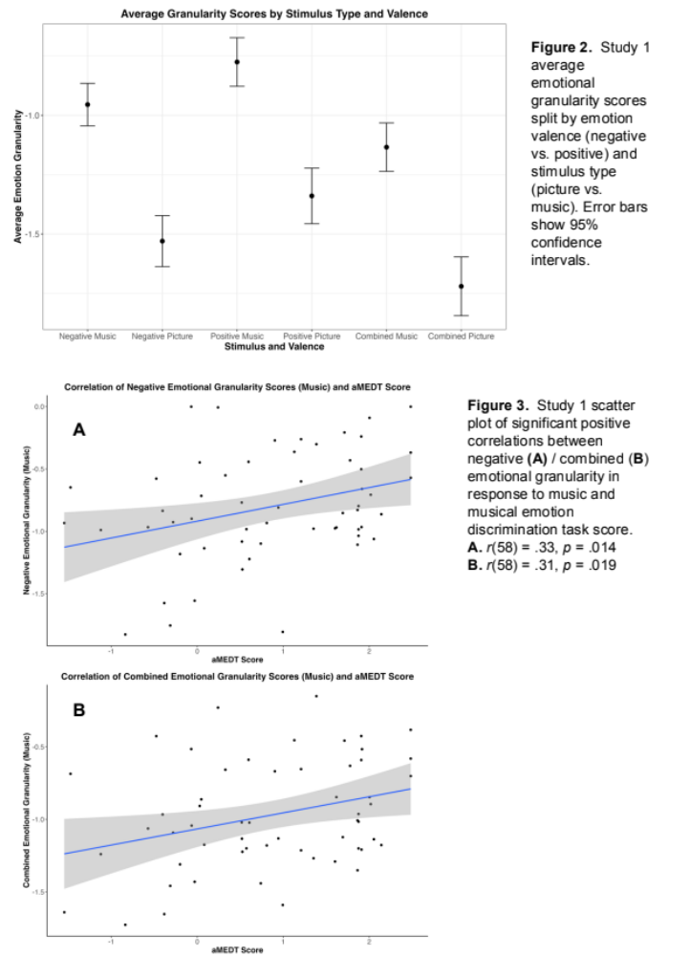
= .09 and p = .49 with pictures (Figure 4B), r(62) = .09 and p = .50 with music (Figure 4A), There was also no significant association found between negative emotional granularity (picture or music) and depression (BDI-II), r(62) = –.15 and p = .27 with pictures (Figure 4D), r(62) = 0 and p = .97 with music (Figure 4C), or negative emotional granularity (picture or music) and anxiety (STAI), r(62) = –.21 and p = .12 with pictures (Figure 4F), r(62) = –.08 and p = .54 with music (Figure 4E).
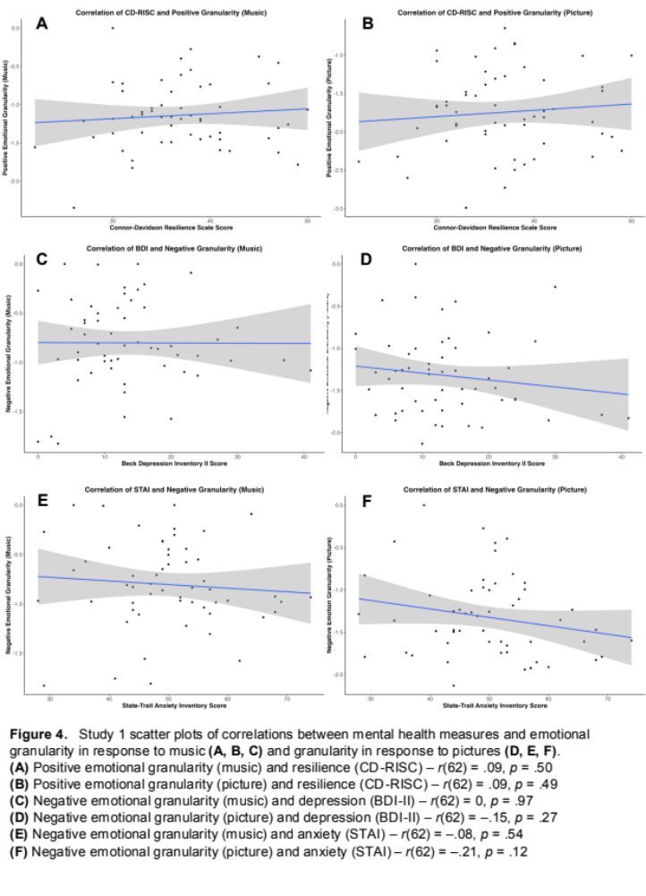
STUDY 2
MATERIALS AND METHODS
Participants
Study 2 consisted of 50 participants who all completed the study in-person at Northeastern University’s Interdisciplinary Science and Engineering Complex as part of a series of tasks for other studies at the Music, Imaging, and Neural Dynamics Lab. Participants were recruited from the Greater Boston area. 4 of the participants were individuals that were sent the emotion rating task and aMEDT as optional follow-up tasks after having previously participated in a study at the MIND Lab prior to the start of data collection for this study. Those 4 completed the tasks online, while the other 46 completed the tasks in the MIND Lab space in-person. Demographic data for the sample are shown in Table 2. All subjects gave written informed consent.
Table 2 Study 2 sample demographics
Demographic | Study 2 sample  (n = 50)
Age
Mean (SD) | 21 (1.32)
Range | 18–24 years
Sex
Male | 22 (44%)
Female | 28 (56%)
Gender
Man | 22 (44%)
Woman | 27 (54%)
Non-binary | 1 (2%)
Race/Ethnicity
American Indian or Alaska Native | 0 (0%)
Asian | 15 (30%)
Black or African American | 2 (4%)
Hispanic or Latino | 0 (0%)
Native Hawaiian or Other Pacific Islander | 0 (0%)
White | 21 (42%)
Two or more races | 12 (24%)
Demographic information for the Study 2 sample
Materials
The same emotion rating task and aMEDT from Study 1 were administered in Study 2. High-resolution anatomical images were acquired in ##NEED NORTHEASTERN’S MRI DETAILS. Anatomical images were obtained using a T1-weighted image ##Need to finish this
Procedure
Participants completed the study in two separate sessions on separate days. The aMEDT was one of the tasks completed on the first day, and the emotion rating task and MRI were part of the second day. Most participants completed the emotion rating task before entering the scanner, but some completed it afterwards. In the MRI, patients remained awake and watching short films while structural scans were completed. The 4 participants mentioned in Participants completed both tasks online after having already completed their two sessions. This sample did not complete the Qualtrics survey done in Study 1.
Analysis Plan
The emotion rating task and aMEDT were analyzed as in Study 1.
The anatomical data preprocessing was done through FreeSurfer using a T1-weighted image and recon-all for cortical surface reconstruction. This returned measures of cortical thickness and subcortical volume measures. The Destrieux atlas (aparc.a2009s) was used in order to isolate the inferior frontal cortex ROIs, given that the Destrieux atlas is parcellated into 148 ROIs while the Desikan-Killiany atlas (default for FreeSurfer aparc_stats) is parcellated into 68 ROIs (Figure 5A). Specific ROIs in the inferior frontal cortex were selected based on those analyzed in Lukic et al. (2023): the posterior inferior frontal gyrus, comprising of pars opercularis (BA44) and pars triangularis (BA45), the lateral orbitofrontal cortex, comprising of pars orbitalis (BA47), BA12, and BA11, and the dorsal anterior insula (Figure 5B). The Destrieux atlas includes BA44, BA45, and BA47 explicitly and were analyzed as such. The other regions were approximated using the broader orbitofrontal gyrus thickness for BA12, lateral sulcus and H-shaped orbital sulcus for BA12, and the larger gyrus of the insula and superior circular sulcus of the insula for the dorsal anterior insula, for a total of eight ROIs from the atlas. Parcellation statistics of cortical thickness for both hemispheres for these regions were analyzed for Pearson’s correlations with all six granularity scores for participants.
RESULTS
Each participant completed the granularity task and had six emotional granularity scores calculated based on their emotion response ratings: positive emotional granularity in response to music (M = –0.99, SD = 0.48, range = –2.54 to –0.28) and in response to pictures (M = –1.59, SD = 0.55, range = –2.97 to 0), negative emotional granularity in response to music (M = –0.64, SD = 0.40, range = –1.51 to 0) and in response to pictures (M = –1.38, SD = 0.49, range = –2.69 to –0), and combined emotional granularity as an average of an individual’s positive and negative 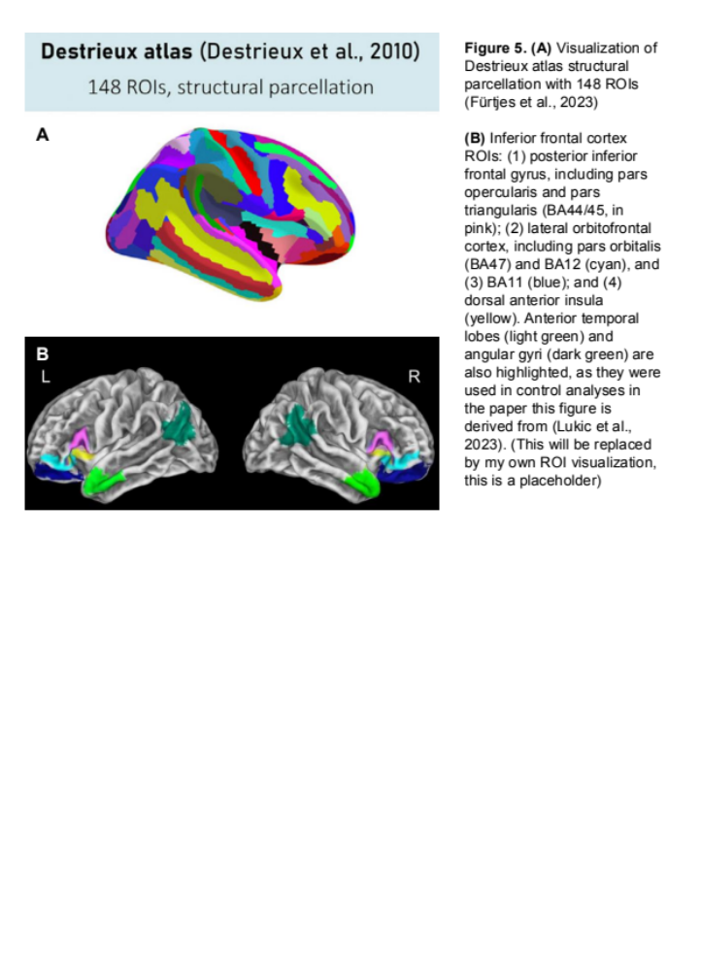granularity scores for music (M = –0.81, SD = 0.38, range = –1.79 to –0.24) and pictures (M = –1.48, SD = 0.47, range = –2.58 to 0) (Figure 6A–C).
We first examined the relationship between emotional granularity measures in response to pictures and in response to music, separating by positive, negative, and combined scores (Figure 6D–F). Positive emotional granularity scores in response to music were found to be significantly positively correlated with positive granularity scores in response to pictures, r(48) = .65, p < .001. Negative emotional granularity scores were similarly positively correlated, r(48) = .62, p < .001, as was combined granularity, r(48) = .73, p < .001. Emotional granularity in response to music was greater for music compared to pictures for positive (t(49) = 9.86 and p < 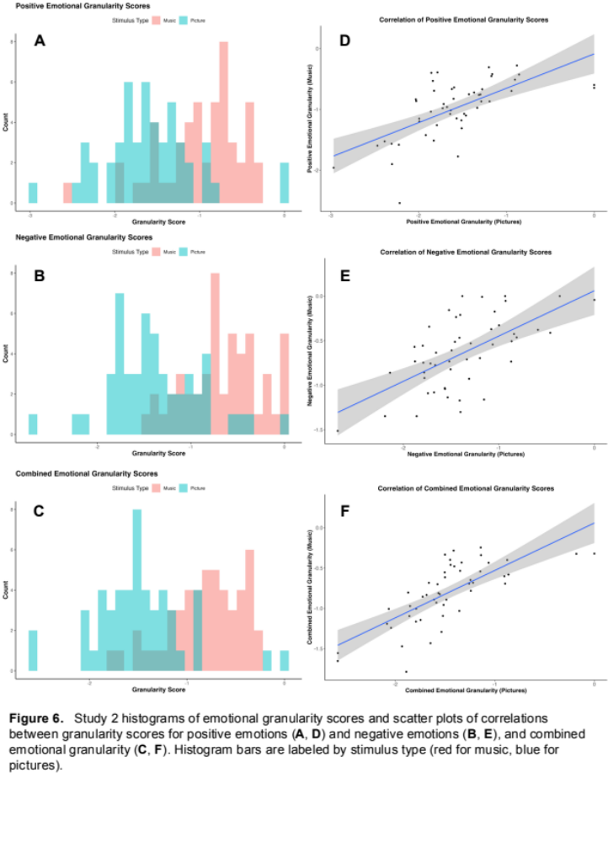.001), negative (t(49) = 13.28 and p < .001), and combined (t(49) = 14.67 and p < .001) granularity scores (Figure 7). 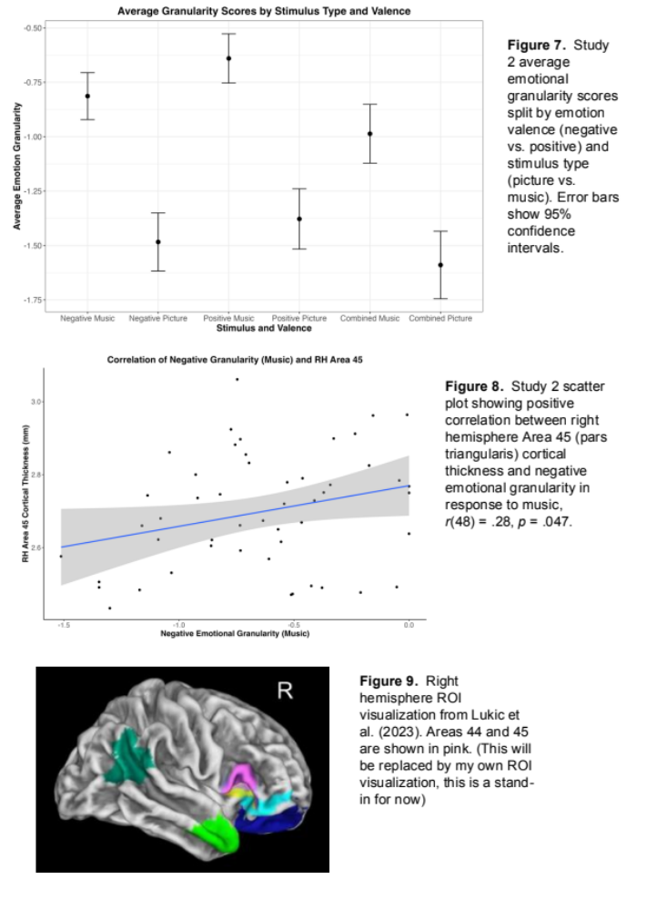
Our final sample size for the aMEDT was 48 due to missing data from 2 participants. We examined the relationship between emotional granularity in response to music and emotion discrimination within music (based on the aMEDT), finding no significant correlations between musical emotion discrimination ability scores and positive emotion granularity in response to music, r(46) = –.07, p = .62, negative emotion granularity in response to music, r(46) = –.21 and p = .15, or combined emotional granularity in response to music, r(46) = –.15 and p = .29.
With the eight ROIs we identified, a positive correlation was found between the cortical thickness of the right hemisphere BA45, pars triangularis, and negative emotional granularity in response to music, r(48) = .28 and p = .047 (Figure 8). Pars triangularis comprises a part of the pink highlighted portion in Figure 9.
DISCUSSION (this section needs to be expanded)
Our results for both Study 1 and Study 2 aligned with our prediction that emotional granularity in response to music stimuli would be positively correlated with granularity in response to picture stimuli. This helps to validate that the type of emotional granularity measured using music stimuli is the same kind of granularity typically measured by responses to standardized picture stimuli, suggesting that music stimuli could be an effective way to measure emotional granularity. In both studies, all granularity scores calculated bases on emotion responses to music stimuli were also greater in magnitude than those based on picture stimuli. This suggests that greater emotion differentiation is experienced in response to music than in response to picture stimuli, with musical stimuli eliciting a higher degree of emotional granularity than picture stimuli, in accordance with our hypothesis. This may potentially be a result of the dynamic nature of music as it unfolds through time, allowing for more differentiable emotional experiences. Given that one particular concern with studying emotional granularity with static images is its low ecological validity, the higher level of emotional granularity found using music may make it more similar to experience sampling without the costs and challenges inherent to experience sampling.
The positive correlation we found between cortical thickness in the right hemisphere pars triangularis (BA45) and negative emotional granularity in response to music replicates at least part of the findings in Lukic et al. (2023), which found a positive correlation between emotional granularity and inferior frontal cortex cortical thickness. Importantly, Lukic et al. (2023) collected data over the course of 8 weeks with participants completing daily experience surveys. The higher ecological validity of this kind of emotional granularity study may explain part of the discrepancy (i.e., our lack of correlations for other IFC regions). Nonetheless, the correlation found here with BA45 is intriguing given the role of pars triangularis in speech production as well as greater elements of semantic processing. While the left hemispheric portion of BA45 is the one typically associated with speech production, the right hemisphere serves similar purposes, albeit potentially to a lesser extent (NEED TO FIND SOURCE it is so hard to find). Additionally, given that the distinction between BA44 and BA45 is not always clear, there may be methodological issues with the parcellation used that made it more difficult to find any significant correlations with the left half of BA44. (This paragraph needs to be much longer and also I need a segue to the rest of the discussion or maybe move this part)
The two instances of significant correlations between musical emotion discrimination ability and emotional granularity were in Study 1 with negative emotional granularity in response to music as well as combined granularity in response to music. The lack of strong correlation otherwise, particularly with no correlations found in Study 2, suggests that emotion perception may not necessarily require the same abilities as emotion differentiation. Being able to detect the emotion that is intended to be portrayed by something does not necessarily suggest a stronger ability to understand one’s own emotional experiences. Emotion perception, particularly in music, may just be a learned ability involving identifying specific tonal qualities and knowing what emotions they’re associated with. For example, in the stimuli presented in the aMEDT, excerpts intended to be “angry” are generally at a louder dynamic with accented articulations (sometimes marcato, sometimes staccato) and bright overtones, whereas “happy” excerpts are at a loud dynamic with more legato phrasing and less harsh overtones. It is entirely possible to learn these characteristics without needing any connection to one’s own emotional states.
We initially expected to see a positive correlation between positive emotional granularity and resilience (Tugade et al., 2004), a negative correlation between negative granularity and depression (Willroth et al., 2020), and a negative correlation between negative granularity and anxiety (Seah et al., 2020; Erbas et al., 2014). While we did not observe these and therefore did not replicate these findings from existing literature, it is possible that this is tied to the challenges of granularity studies that aren’t based on experience-sampling. The challenge of maintaining high ecological validity with standardized stimulus response tasks is not one that will be overcome as simply as by changing the types of stimuli. However, that isn’t to say that these tasks cannot be improved to be at least somewhat more representative of daily experiences of emotions. Given music’s ability to unfold over time and bring listeners through different affective states, as well as our findings in this study, music may be an effective step forward with improving the methodologies for studying the complexities of emotional granularity.

References
Altenmüller, E., Schürmann, K., Lim, V. K., & Parlitz, D. (2002). Hits to the left, flops to the right: Different emotions during listening to music are reflected in cortical lateralisation patterns. Neuropsychologia, 40(13), 2242–2256. https://doi.org/10.1016/S0028-3932(02)00107-0
Anand, D., Chen, Y., Lindquist, K. A., & Daughters, S. B. (2017). Emotion differentiation predicts likelihood of initial lapse following substance use treatment. Drug and Alcohol Dependence, 180, 439–444. https://doi.org/10.1016/j.drugalcdep.2017.09.007
Aron, A. R., Robbins, T. W., & Poldrack, R. A. (2004). Inhibition and the right inferior frontal cortex. Trends in Cognitive Sciences, 8(4), 170–177. https://doi.org/10.1016/j.tics.2004.02.010
Aron, A. R., Robbins, T. W., & Poldrack, R. A. (2014). Right inferior frontal cortex: Addressing the rebuttals. Frontiers in Human Neuroscience, 8. https://doi.org/10.3389/fnhum.2014.00905
Bachorik, J. P., Bangert, M., Loui, P., Larke, K., Berger, J., Rowe, R., & Schlaug, G. (2009). Emotion in Motion: Investigating the Time-Course of Emotional Judgments of Musical Stimuli. Music Perception, 26(4), 355–364. https://doi.org/10.1525/mp.2009.26.4.355
Baron-Cohen, S., Golan, O., Wheelwright, S., Granader, Y., & Hill, J. (2010). Emotion Word Comprehension from 4 to 16 Years Old: A Developmental Survey. Frontiers in Evolutionary Neuroscience, 2, 109. https://doi.org/10.3389/fnevo.2010.00109
Barrett, L. F. (2006). Solving the Emotion Paradox: Categorization and the Experience of Emotion. Personality and Social Psychology Review, 10(1), 20–46. https://doi.org/10.1207/s15327957pspr1001_2
Barrett, L. F. (2017). The theory of constructed emotion: An active inference account of interoception and categorization. Social Cognitive and Affective Neuroscience, 12(1), 1–23. https://doi.org/10.1093/scan/nsw154
Barrett, L. F., Gross, J., Christensen, T. C., & Benvenuto, M. (2001). Knowing what you’re feeling and knowing what to do about it: Mapping the relation between emotion differentiation and emotion regulation. Cognition and Emotion, 15(6), 713–724. https://doi.org/10.1080/02699930143000239
Baumgartner, T., Esslen, M., & Jäncke, L. (2006). From emotion perception to emotion experience: Emotions evoked by pictures and classical music. International Journal of Psychophysiology, 60(1), 34–43. https://doi.org/10.1016/j.ijpsycho.2005.04.007
Beck, A. T., Steer, R. A., & Brown, G. (1996). Beck Depression Inventory–II [Dataset]. https://doi.org/10.1037/t00742-000
Behne, K.-E. (1997). The development of Musikerleben in adolescence: How and why young people listen to music. In I. Deliège & J. A. Sloboda (Eds.), Perception and Cognition of Music (pp. 143–159). Psychology Press.
Block, J., & Kremen, A. M. (1996). IQ and ego-resiliency: Conceptual and empirical connections and separateness. Journal of Personality and Social Psychology, 70(2), 349–361. https://doi.org/10.1037/0022-3514.70.2.349
Blood, A. J., & Zatorre, R. J. (2001). Intensely pleasurable responses to music correlate with activity in brain regions implicated in reward and emotion. Proceedings of the National Academy of Sciences, 98(20), 11818–11823. https://doi.org/10.1073/pnas.191355898
Brattico, E., & Jacobsen, T. (2009). Subjective Appraisal of Music. Annals of the New York Academy of Sciences, 1169(1), 308–317. https://doi.org/10.1111/j.1749-6632.2009.04843.x
Brooks, J. A., Shablack, H., Gendron, M., Satpute, A. B., Parrish, M. H., & Lindquist, K. A. (2017). The role of language in the experience and perception of emotion: A neuroimaging meta-analysis. Social Cognitive and Affective Neuroscience, 12(2), 169–183. https://doi.org/10.1093/scan/nsw121
Brown, S., Martinez, M. J., & Parsons, L. M. (2004). Passive music listening spontaneously engages limbic and paralimbic systems. NeuroReport, 15(13), 2033–2037.
Canu, E., Calderaro, D., Castelnovo, V., Basaia, S., Magno, M. A., Riva, N., Magnani, G., Caso, F., Caroppo, P., Prioni, S., Villa, C., Pain, D., Mora, G., Tremolizzo, L., Appollonio, I., Poletti, B., Silani, V., Filippi, M., & Agosta, F. (2022). Resting state functional brain networks associated with emotion processing in frontotemporal lobar degeneration. Molecular Psychiatry, 27(11), 4809–4821. https://doi.org/10.1038/s41380-022-01612-9
Cardona, G., Ferreri, L., Lorenzo-Seva, U., Russo, F. A., & Rodriguez-Fornells, A. (2022). The forgotten role of absorption in music reward. Annals of the New York Academy of Sciences, 1514(1), 142–154. https://doi.org/10.1111/nyas.14790
Coan, J. A., & Allen, J. J. B. (2007). Handbook of Emotion Elicitation and Assessment. Oxford University Press, USA.
Connor, K. M., & Davidson, J. R. T. (2003). Development of a new resilience scale: The Connor-Davidson Resilience Scale (CD-RISC). Depression and Anxiety, 18(2), 76–82. https://doi.org/10.1002/da.10113
Dellacherie, D., Ehrlé, N., & Samson, S. (2008). Is the neutral condition relevant to study musical emotion in patients? Music Perception, 25(4), 285–294. https://doi.org/10.1525/mp.2008.25.4.285
DeNora, T. (1999). Music as a technology of the self. Poetics, 27(1), 31–56. https://doi.org/10.1016/S0304-422X(99)00017-0
Destrieux, C., Fischl, B., Dale, A., & Halgren, E. (2010). Automatic parcellation of human cortical gyri and sulci using standard anatomical nomenclature. NeuroImage, 53(1), 1–15. https://doi.org/10.1016/j.neuroimage.2010.06.010
Dörfel, D., Lamke, J.-P., Hummel, F., Wagner, U., Erk, S., & Walter, H. (2014). Common and differential neural networks of emotion regulation by Detachment, Reinterpretation, Distraction, and Expressive Suppression: A comparative fMRI investigation. NeuroImage, 101, 298–309. https://doi.org/10.1016/j.neuroimage.2014.06.051
Dubé, L., & Le Bel, J. (2003). The content and structure of laypeople’s concept of pleasure. Cognition and Emotion, 17(2), 263–295. https://doi.org/10.1080/02699930302295
Eerola, T., & Saari, P. (2025). What emotions does music express? Structure of affect terms in music using iterative crowdsourcing paradigm. PLOS ONE, 20(1), e0313502. https://doi.org/10.1371/journal.pone.0313502
Erbas, Y., Ceulemans, E., Blanke, E. S., Sels, L., Fischer, A., & Kuppens, P. (2019). Emotion differentiation dissected: Between-category, within-category, and integral emotion differentiation, and their relation to well-being. Cognition and Emotion, 33(2), 258–271. https://doi.org/10.1080/02699931.2018.1465894
Erbas, Y., Ceulemans, E., Kalokerinos, E. K., Houben, M., Koval, P., Pe, M. L., & Kuppens, P. (2018). Why I don’t always know what I’m feeling: The role of stress in within-person fluctuations in emotion differentiation. Journal of Personality and Social Psychology, 115(2), 179–191. https://doi.org/10.1037/pspa0000126
Erbas, Y., Ceulemans, E., Lee Pe, M., Koval, P., & Kuppens, P. (2014). Negative emotion differentiation: Its personality and well-being correlates and a comparison of different assessment methods. Cognition and Emotion, 28(7), 1196–1213. https://doi.org/10.1080/02699931.2013.875890
Erbas, Y., Kalokerinos, E. K., Kuppens, P., van Halem, S., & Ceulemans, E. (2022). Momentary Emotion Differentiation: The Derivation and Validation of an index to Study Within-Person Fluctuations in Emotion Differentiation. Assessment, 29(4), 700–716. https://doi.org/10.1177/1073191121990089
Fürtjes, A. E., Cole, J. H., Couvy-Duchesne, B., & Ritchie, S. J. (2023). A quantified comparison of cortical atlases on the basis of trait morphometricity. Cortex, 158, 110–126. https://doi.org/10.1016/j.cortex.2022.11.001
Gabrielsson, A. (2001). Emotions in strong experiences with music. In P. N. Juslin & J. A. Sloboda (Eds.), Music and emotion: Theory and research (pp. 431–449). Oxford University Press.
Gabrielsson, A. (2010). Strong Experiences with Music. In P. N. Juslin (Ed.), Handbook of Music and Emotion: Theory, Research, Applications (p. 0). Oxford University Press. https://doi.org/10.1093/acprof:oso/9780199230143.003.0020
Glenn Schellenberg, E. (2003). Does Exposure to Music Have Beneficial Side Effects? In I. Peretz & R. J. Zatorre (Eds.), The Cognitive Neuroscience of Music (p. 0). Oxford University Press. https://doi.org/10.1093/acprof:oso/9780198525202.003.0028
Goldin, P. R., McRae, K., Ramel, W., & Gross, J. J. (2008). The Neural Bases of Emotion Regulation: Reappraisal and Suppression of Negative Emotion. Biological Psychiatry, 63(6), 577–586. https://doi.org/10.1016/j.biopsych.2007.05.031
Gosselin, N., Peretz, I., Noulhiane, M., Hasboun, D., Beckett, C., Baulac, M., & Samson, S. (2005). Impaired recognition of scary music following unilateral temporal lobe excision. Brain, 128(3), 628–640. https://doi.org/10.1093/brain/awh420
Gosselin, N., Samson, S., Adolphs, R., Noulhiane, M., Roy, M., Hasboun, D., Baulac, M., & Peretz, I. (2006). Emotional responses to unpleasant music correlates with damage to the parahippocampal cortex. Brain, 129(10), 2585–2592. https://doi.org/10.1093/brain/awl240
Granot, R., Spitz, D. H., Cherki, B. R., Loui, P., Timmers, R., Schaefer, R. S., Vuoskoski, J. K., Cárdenas-Soler, R.-N., Soares-Quadros, J. F., Li, S., Lega, C., La Rocca, S., Martínez, I. C., Tanco, M., Marchiano, M., Martínez-Castilla, P., Pérez-Acosta, G., Martínez-Ezquerro, J. D., Gutiérrez-Blasco, I. M., … Israel, S. (2021). “Help! I Need Somebody”: Music as a Global Resource for Obtaining Wellbeing Goals in Times of Crisis. Frontiers in Psychology, 12. https://doi.org/10.3389/fpsyg.2021.648013
Hariri, A. R., Bookheimer, S. Y., & Mazziotta, J. C. (2000). Modulating emotional responses: Effects of a neocortical network on the limbic system. Neuroreport, 11(1), 43–48. https://doi.org/10.1097/00001756-200001170-00009
Hevner, K. (1936). Experimental Studies of the Elements of Expression in Music. The American Journal of Psychology, 48(2), 246–268. https://doi.org/10.2307/1415746
Hoemann, K., Feldman Barrett, L., & Quigley, K. S. (2021). Emotional Granularity Increases With Intensive Ambulatory Assessment: Methodological and Individual Factors Influence How Much. Frontiers in Psychology, 12. https://doi.org/10.3389/fpsyg.2021.704125
Hoemann, K., Khan, Z., Kamona, N., Dy, J., Barrett, L., & Quigley, K. (2021). Investigating the relationship between emotional granularity and cardiorespiratory physiological activity in daily life. Psychophysiology, 58. https://doi.org/10.1111/psyp.13818
Hoemann, K., Lee, Y., Kuppens, P., Gendron, M., & Boyd, R. L. (2023). Emotional Granularity is Associated with Daily Experiential Diversity. Affective Science, 4(2), 291–306. https://doi.org/10.1007/s42761-023-00185-2
Israelashvili, J., Oosterwijk, S., Sauter, D., & Fischer, A. (2019). Knowing me, knowing you: Emotion differentiation in oneself is associated with recognition of others’ emotions. Cognition and Emotion, 33(7), 1461–1471. https://doi.org/10.1080/02699931.2019.1577221
Jacobson, N. C., Erickson, T. M., Quach, C. M., & Singh, N. B. (2023). Low Emotional Complexity as a Transdiagnostic Risk Factor: Comparing Idiographic Markers of Emotional Complexity to Emotional Granularity as Predictors of Anxiety, Depression, and Personality Pathology. Cognitive Therapy and Research, 47(2), 181–194. https://doi.org/10.1007/s10608-022-10347-4
Jeong, S. S., Gong, Y., & Henderson, A. (2023). Sympathy or distress? The moderating role of negative emotion differentiation in helping behavior. Asia Pacific Journal of Management, 40(4), 1429–1458. https://doi.org/10.1007/s10490-022-09819-8
Juslin, P. N. (2013). From everyday emotions to aesthetic emotions: Towards a unified theory of musical emotions. Physics of Life Reviews, 10(3), 235–266. https://doi.org/10.1016/j.plrev.2013.05.008
Juslin, P. N., & Laukka, P. (2003). Emotional expression in speech and music: Evidence of cross-modal similarities. Annals of the New York Academy of Sciences, 1000, 279–282.
Juslin, P. N., & Sloboda, J. A. (2001). Music and emotion: Theory and research. Oxford University Press.
Kalokerinos, E. K., Erbas, Y., Ceulemans, E., & Kuppens, P. (2019). Differentiate to Regulate: Low Negative Emotion Differentiation Is Associated With Ineffective Use but Not Selection of Emotion-Regulation Strategies. Psychological Science, 30(6), 863–879. https://doi.org/10.1177/0956797619838763
Kang, S.-M., & Shaver, P. R. (2004). Individual Differences in Emotional Complexity: Their Psychological Implications. Journal of Personality, 72(4), 687–726. https://doi.org/10.1111/j.0022-3506.2004.00277.x
Kashdan, T. B., Barrett, L. F., & McKnight, P. E. (2015). Unpacking Emotion Differentiation: Transforming Unpleasant Experience by Perceiving Distinctions in Negativity. Current Directions in Psychological Science, 24(1), 10–16. https://doi.org/10.1177/0963721414550708
Kashdan, T. B., Ferssizidis, P., Collins, R. L., & Muraven, M. (2010). Emotion differentiation as resilience against excessive alcohol use: An ecological momentary assessment in underage social drinkers. Psychological Science, 21(9), 1341–1347. https://doi.org/10.1177/0956797610379863
Kathios, N., Lopez, K., Gabard-Durnam, L. J., & Loui, P. (2023). Music@Home - Retrospective: A New Measure to Retrospectively Assess Childhood Home Musical Environments. OSF. https://doi.org/10.31234/osf.io/csn2m
Kawakami, A., Furukawa, K., & Okanoya, K. (2014). Music evokes vicarious emotions in listeners. Frontiers in Psychology, 5, 431. https://doi.org/10.3389/fpsyg.2014.00431
Khalfa, S., Roy, M., Rainville, P., Dalla Bella, S., & Peretz, I. (2008). Role of tempo entrainment in psychophysiological differentiation of happy and sad music? International Journal of Psychophysiology, 68(1), 17–26. https://doi.org/10.1016/j.ijpsycho.2007.12.001
Koelsch, S. (2014). Brain correlates of music-evoked emotions. Nature Reviews Neuroscience, 15(3), 170–180. https://doi.org/10.1038/nrn3666
Koelsch, S. (2020). A coordinate-based meta-analysis of music-evoked emotions. NeuroImage, 223, 117350. https://doi.org/10.1016/j.neuroimage.2020.117350
Koelsch, S., Fritz, T., v. Cramon, D. Y., Müller, K., & Friederici, A. D. (2006). Investigating emotion with music: An fMRI study. Human Brain Mapping, 27(3), 239–250. https://doi.org/10.1002/hbm.20180
Kragness, H. E., Eitel, M. J., Baksh, A. M., & Trainor, L. J. (2021a). Evidence for early arousal-based differentiation of emotions in children’s musical production. Developmental Science, 24(1), e12982. https://doi.org/10.1111/desc.12982
Kragness, H. E., Eitel, M. J., Baksh, A. M., & Trainor, L. J. (2021b). Evidence for early arousal-based differentiation of emotions in children’s musical production. Developmental Science, 24(1), e12982. https://doi.org/10.1111/desc.12982
Krumhansl, C. L. (1997). An exploratory study of musical emotions and psychophysiology. Canadian Journal of Experimental Psychology / Revue Canadienne de Psychologie Expérimentale, 51(4), 336–353. https://doi.org/10.1037/1196-1961.51.4.336
Kurdi, B., Lozano, S., & Banaji, M. R. (2017). Introducing the Open Affective Standardized Image Set (OASIS). Behavior Research Methods, 49(2), 457–470. https://doi.org/10.3758/s13428-016-0715-3
Lau, E. F., Phillips, C., & Poeppel, D. (2008). A cortical network for semantics: (De)constructing the N400. Nature Reviews Neuroscience, 9(12), 920–933. https://doi.org/10.1038/nrn2532
Lee, J. Y., Lindquist, K. A., & Nam, C. S. (2017). Emotional Granularity Effects on Event-Related Brain Potentials during Affective Picture Processing. Frontiers in Human Neuroscience, 11. https://doi.org/10.3389/fnhum.2017.00133
Levy, B. J., & Wagner, A. D. (2011). Cognitive control and right ventrolateral prefrontal cortex: Reflexive reorienting, motor inhibition, and action updating. Annals of the New York Academy of Sciences, 1224(1), 40–62. https://doi.org/10.1111/j.1749-6632.2011.05958.x
Li, W., Yang, P., Ngetich, R. K., Zhang, J., Jin, Z., & Li, L. (2021). Differential involvement of frontoparietal network and insula cortex in emotion regulation. Neuropsychologia, 161, 107991. https://doi.org/10.1016/j.neuropsychologia.2021.107991
Lieberman, M. D., Hariri, A., Jarcho, J. M., Eisenberger, N. I., & Bookheimer, S. Y. (2005). An fMRI investigation of race-related amygdala activity in African-American and Caucasian-American individuals. Nature Neuroscience, 8(6), 720–722. https://doi.org/10.1038/nn1465
Lindquist, K. A., MacCormack, J. K., & Shablack, H. (2015). The role of language in emotion: Predictions from psychological constructionism. Frontiers in Psychology, 6. https://doi.org/10.3389/fpsyg.2015.00444
Lukic, S., Kosik, E. L., Roy, A. R. K., Morris, N., Sible, I. J., Datta, S., Chow, T., Veziris, C. R., Holley, S. R., Kramer, J. H., Miller, B. L., Keltner, D., Gorno-Tempini, M. L., & Sturm, V. E. (2023). Higher emotional granularity relates to greater inferior frontal cortex cortical thickness in healthy, older adults. Cognitive, Affective, & Behavioral Neuroscience, 23(5), 1401–1413. https://doi.org/10.3758/s13415-023-01119-y
MacGregor, C., Ruth, N., & Müllensiefen, D. (2023). Development and validation of the first adaptive test of emotion perception in music. Cognition and Emotion, 37(2), 284–302. https://doi.org/10.1080/02699931.2022.2162003
Mas-Herrero, E., Marco-Pallares, J., Lorenzo-Seva, U., Zatorre, R. J., & Rodriguez-Fornells, A. (2013). Individual Differences in Music Reward Experiences. Music Perception, 31(2), 118–138. https://doi.org/10.1525/mp.2013.31.2.118
Mitterschiffthaler, M. T., Fu, C. H. Y., Dalton, J. A., Andrew, C. M., & Williams, S. C. R. (2007). A functional MRI study of happy and sad affective states induced by classical music. Human Brain Mapping, 28(11), 1150–1162. https://doi.org/10.1002/hbm.20337
Müllensiefen, D., Gingras, B., Musil, J., & Stewart, L. (2014). The musicality of non-musicians: An index for assessing musical sophistication in the general population. PloS One, 9(2), e89642. https://doi.org/10.1371/journal.pone.0089642
Nook, E. C., Flournoy, J. C., Rodman, A. M., Mair, P., & McLaughlin, K. A. (2021). High Emotion Differentiation Buffers Against Internalizing Symptoms Following Exposure to Stressful Life Events in Adolescence: An Intensive Longitudinal Study. Clinical Psychological Science, 9(4), 699–718. https://doi.org/10.1177/2167702620979786
Nook, E. C., Sasse, S. F., Lambert, H. K., McLaughlin, K. A., & Somerville, L. H. (2017). Increasing verbal knowledge mediates development of multidimensional emotion representations. Nature Human Behaviour, 1, 881–889. https://doi.org/10.1038/s41562-017-0238-7
Nook, E. C., Sasse, S. F., Lambert, H. K., McLaughlin, K. A., & Somerville, L. H. (2018). The Nonlinear Development of Emotion Differentiation: Granular Emotional Experience Is Low in Adolescence. Psychological Science, 29(8), 1346–1357. https://doi.org/10.1177/0956797618773357
Ochsner, K. N., Ray, R. D., Cooper, J. C., Robertson, E. R., Chopra, S., Gabrieli, J. D. E., & Gross, J. J. (2004). For better or for worse: Neural systems supporting the cognitive down- and up-regulation of negative emotion. NeuroImage, 23(2), 483–499. https://doi.org/10.1016/j.neuroimage.2004.06.030
Panksepp, J., & Bernatzky, G. (2002). Emotional sounds and the brain: The neuro-affective foundations of musical appreciation. Behavioural Processes, 60(2), 133–155. https://doi.org/10.1016/S0376-6357(02)00080-3
Paquette, S., Peretz, I., & Belin, P. (2013). The “Musical Emotional Bursts”: A validated set of musical affect bursts to investigate auditory affective processing. Frontiers in Psychology, 4. https://doi.org/10.3389/fpsyg.2013.00509
Pelletier, C. L. (2004). The Effect of Music on Decreasing Arousal Due to Stress: A Meta-Analysis. Journal of Music Therapy, 41(3), 192–214. https://doi.org/10.1093/jmt/41.3.192
Phan, K. L., Fitzgerald, D. A., Nathan, P. J., Moore, G. J., Uhde, T. W., & Tancer, M. E. (2005). Neural substrates for voluntary suppression of negative affect: A functional magnetic resonance imaging study. Biological Psychiatry, 57(3), 210–219. https://doi.org/10.1016/j.biopsych.2004.10.030
Picó-Pérez, M., Alemany-Navarro, M., Dunsmoor, J. E., Radua, J., Albajes-Eizagirre, A., Vervliet, B., Cardoner, N., Benet, O., Harrison, B. J., Soriano-Mas, C., & Fullana, M. A. (2019). Common and distinct neural correlates of fear extinction and cognitive reappraisal: A meta-analysis of fMRI studies. Neuroscience and Biobehavioral Reviews, 104, 102–115. https://doi.org/10.1016/j.neubiorev.2019.06.029
Pond, R. S., Kashdan, T. B., DeWall, C. N., Savostyanova, A., Lambert, N. M., & Fincham, F. D. (2012). Emotion differentiation moderates aggressive tendencies in angry people: A daily diary analysis. Emotion (Washington, D.C.), 12(2), 326–337. https://doi.org/10.1037/a0025762
Sachs, M. E., Ochsner, K. N., & Baldassano, C. (2023). Brain state dynamics reflect emotion transitions induced by music (p. 2023.03.01.530528). bioRxiv. https://doi.org/10.1101/2023.03.01.530528
Salimpoor, V. N., Benovoy, M., Larcher, K., Dagher, A., & Zatorre, R. J. (2011). Anatomically distinct dopamine release during anticipation and experience of peak emotion to music. Nature Neuroscience, 14(2), 257–262. https://doi.org/10.1038/nn.2726
Salimpoor, V. N., Benovoy, M., Longo, G., Cooperstock, J. R., & Zatorre, R. J. (2009). The Rewarding Aspects of Music Listening Are Related to Degree of Emotional Arousal. PLoS One, 4(10), e7487. https://doi.org/10.1371/journal.pone.0007487
Schaefer, H.-E. (2017a). Music-Evoked Emotions—Current Studies. Frontiers in Neuroscience, 11. https://doi.org/10.3389/fnins.2017.00600
Schaefer, H.-E. (2017b). Music-Evoked Emotions—Current Studies. Frontiers in Neuroscience, 11. https://doi.org/10.3389/fnins.2017.00600
Seah, T. H. S., Aurora, P., & Coifman, K. G. (2020). Emotion Differentiation as a Protective Factor Against the Behavioral Consequences of Rumination: A Conceptual Replication and Extension in the Context of Social Anxiety. Behavior Therapy, 51(1), 135–148. https://doi.org/10.1016/j.beth.2019.05.011
Shrout, P. E., & Fleiss, J. L. (1979). Intraclass correlations: Uses in assessing rater reliability. Psychological Bulletin, 86(2), 420–428. https://doi.org/10.1037//0033-2909.86.2.420
Sloboda, J. A. (2010). Music in Everyday Life: The Role of Emotions. In P. N. Juslin (Ed.), Handbook of Music and Emotion: Theory, Research, Applications (p. 0). Oxford University Press. https://doi.org/10.1093/acprof:oso/9780199230143.003.0018
Sloboda, J. A., & Juslin, P. N. (2001). Psychological perspectives on music and emotion. In J. A. Sloboda & P. N. Juslin (Eds.), Music and emotion: Theory and research (pp. 71–104). Oxford University Press.
Sloboda, J. A., & O’Neill, S. A. (2001). Emotions in everyday listening to music. In J. A. Sloboda & P. N. Juslin (Eds.), Music and emotion: Theory and research (pp. 415–429). Oxford University Press.
Spielberger, C. D. (1983). State-Trait Anxiety Inventory for Adults [Dataset]. https://doi.org/10.1037/t06496-000
Starr, L. R., Hershenberg, R., Li, Y. I., & Shaw, Z. A. (2017). When Feelings Lack Precision: Low Positive and Negative Emotion Differentiation and Depressive Symptoms in Daily Life. Clinical Psychological Science, 5(4), 613–631. https://doi.org/10.1177/2167702617694657
Starr, L. R., Hershenberg, R., Shaw, Z. A., Li, Y. I., & Santee, A. C. (2020). The perils of murky emotions: Emotion differentiation moderates the prospective relationship between naturalistic stress exposure and adolescent depression: Emotion. Emotion, 20(6), 927–938. https://doi.org/10.1037/emo0000630
Tan, T. Y., Wachsmuth, L., & Tugade, M. M. (2022). Emotional Nuance: Examining Positive Emotional Granularity and Well-Being. Frontiers in Psychology, 13. https://www.frontiersin.org/articles/10.3389/fpsyg.2022.715966
Thoma, M. V., Ryf, S., Mohiyeddini, C., Ehlert, U., & Nater, U. M. (2012). Emotion regulation through listening to music in everyday situations. Cognition and Emotion, 26(3), 550–560. https://doi.org/10.1080/02699931.2011.595390
Thompson, R. J., Springstein, T., & Boden, M. (2021). Gaining clarity about emotion differentiation. Social and Personality Psychology Compass, 15(3), e12584. https://doi.org/10.1111/spc3.12584
Thompson-Schill, S. L., D’Esposito, M., Aguirre, G. K., & Farah, M. J. (1997). Role of left inferior prefrontal cortex in retrieval of semantic knowledge: A reevaluation. Proceedings of the National Academy of Sciences of the United States of America, 94(26), 14792–14797. https://doi.org/10.1073/pnas.94.26.14792
Torre, J. B., & Lieberman, M. D. (2018). Putting Feelings Into Words: Affect Labeling as Implicit Emotion Regulation. Emotion Review, 10(2), 116–124. https://doi.org/10.1177/1754073917742706
Tugade, M. M., Fredrickson, B. L., & Barrett, L. F. (2004). Psychological Resilience and Positive Emotional Granularity: Examining the Benefits of Positive Emotions on Coping and Health. Journal of Personality, 72(6), 1161–1190. https://doi.org/10.1111/j.1467-6494.2004.00294.x
Vedernikova, E., Kuppens, P., & Erbas, Y. (2021). From Knowledge to Differentiation: Increasing Emotion Knowledge Through an Intervention Increases Negative Emotion Differentiation. Frontiers in Psychology, 12. https://doi.org/10.3389/fpsyg.2021.703757
Vidas, D., Calligeros, R., Nelson, N. L., & Dingle, G. A. (2020). Development of emotion recognition in popular music and vocal bursts. Cognition & Emotion, 34(5), 906–919. https://doi.org/10.1080/02699931.2019.1700482
Watson, R., & de Gelder, B. (2017). How white and black bodies are perceived depends on what emotion is expressed. Scientific Reports, 7(1), 41349. https://doi.org/10.1038/srep41349
Wells, A., & Hakanen, E. A. (1991). The Emotional Use of Popular Music by Adolescents. Journalism Quarterly, 68(3), 445–454.
Willroth, E. C., Flett, J. A. M., & Mauss, I. B. (2020). Depressive symptoms and deficits in stress-reactive negative, positive, and within-emotion-category differentiation: A daily diary study. Journal of Personality, 88(2), 174–184. https://doi.org/10.1111/jopy.12475
Wilson-Mendenhall, C. D., & Dunne, J. D. (2021). Cultivating Emotional Granularity. Frontiers in Psychology, 12. https://www.frontiersin.org/articles/10.3389/fpsyg.2021.703658
Zald, D. H., & Zatorre, R. J. (2011). Music. In J. A. Gottfried (Ed.), Neurobiology of Sensation and Reward. CRC Press/Taylor & Francis. http://www.ncbi.nlm.nih.gov/books/NBK92781/
Zillman, D., & Gan, S. (1997). Musical taste in adolescence. In D. J. Hargreaves & A. C. North (Eds.), The social psychology of music (pp. 161–187). Oxford University Press.

